Technical Staff Details

Name  Mrs. Dipika J. Patel | Responsibility | Contact details
Designiation  Jr. Clerk | Reception  Account Department | +91 2692-234966 (O)  +91 99749 36030 (M)
Photo  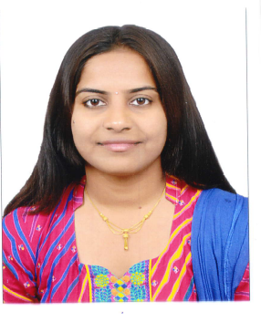 | Reception  Account Department | +91 2692-234966 (O)  +91 99749 36030 (M)
For more information  (Brief Biodata) | Reception  Account Department | +91 2692-234966 (O)  +91 99749 36030 (M)

Brief Biodata

1 | Name | Mrs. Dipika J. Patel
2 | Organization | Sophisticated Instrumentation Centre  For Applied Research & Testing (SICART),  Vallabh Vidyanagar- 388120, Anand, Gujarat
3 | Academic Qualification | B.Com
4 | Sophisticated Instrumentation Handling/ Research Experience | Reception  Account Department
5 | Major Achievements | ---
6 | Other Details (If any) | --

